Project Screenshots

**Initial creation:**

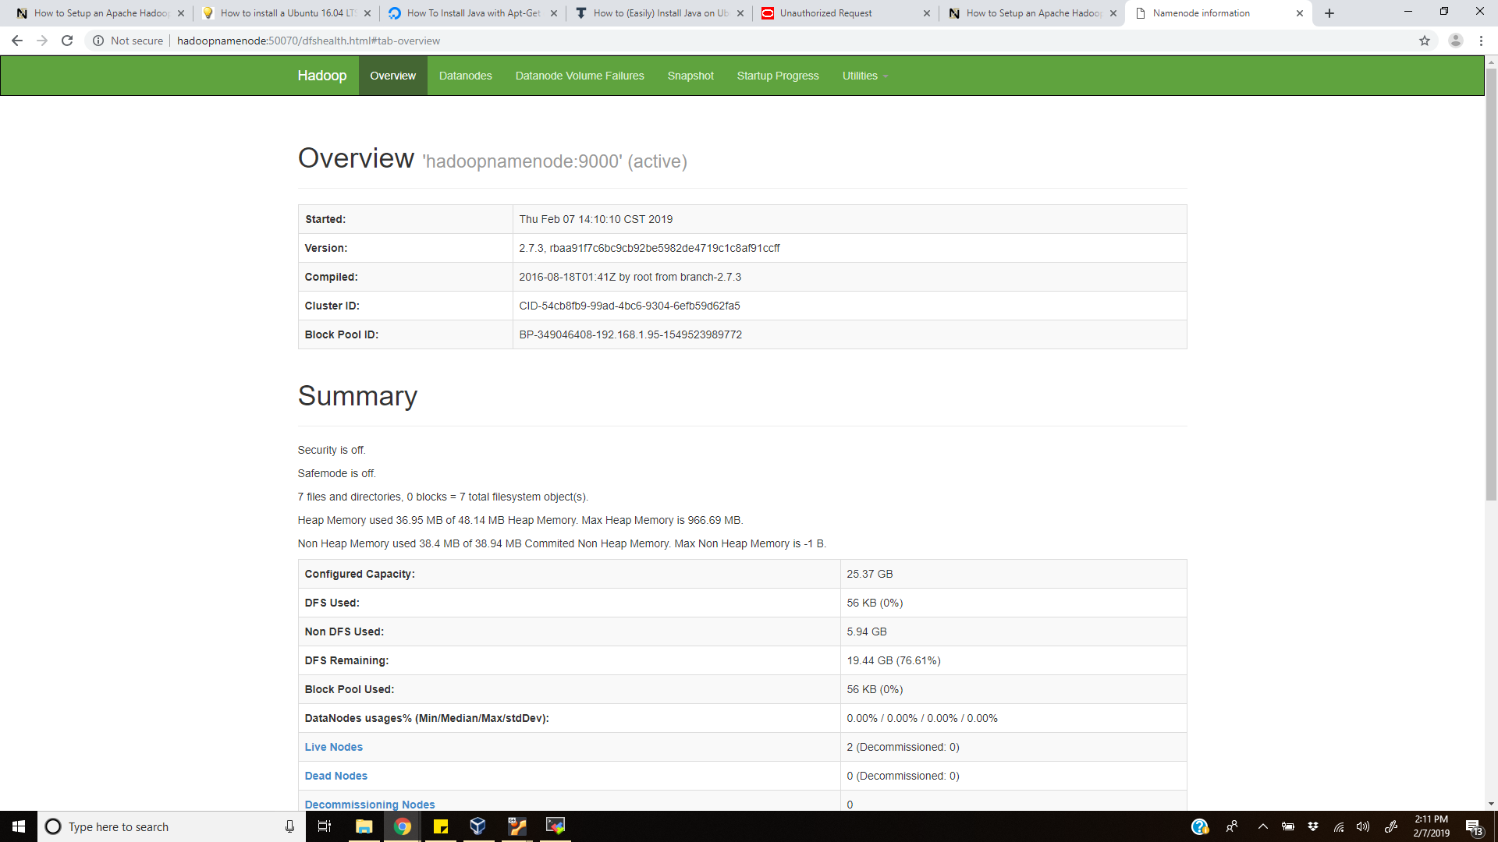

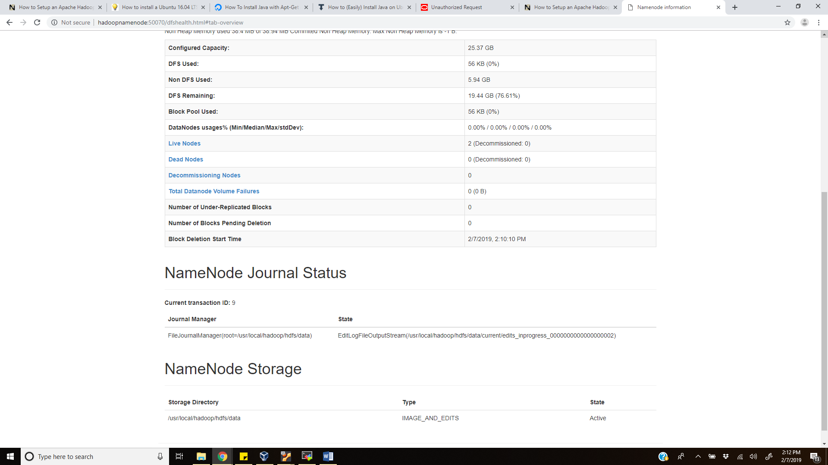

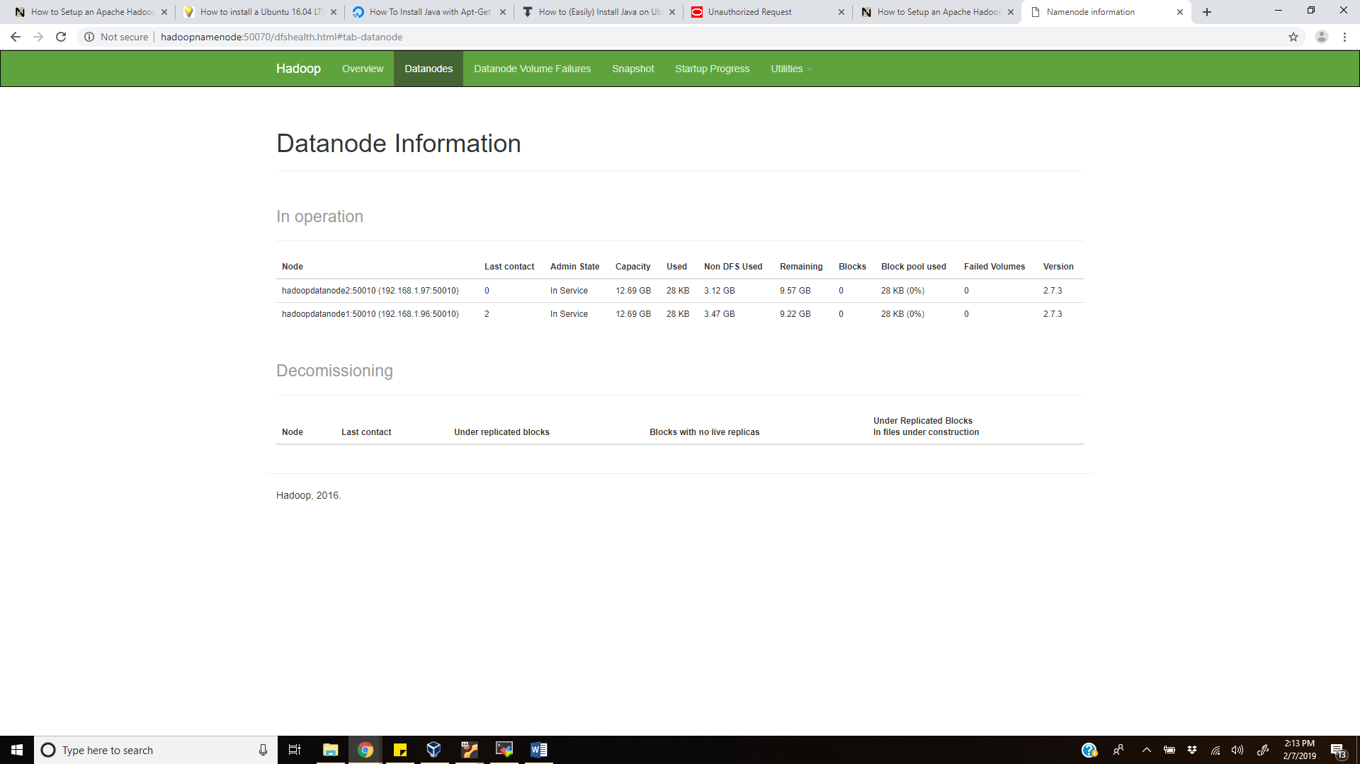

**After storing data in hdfs:**

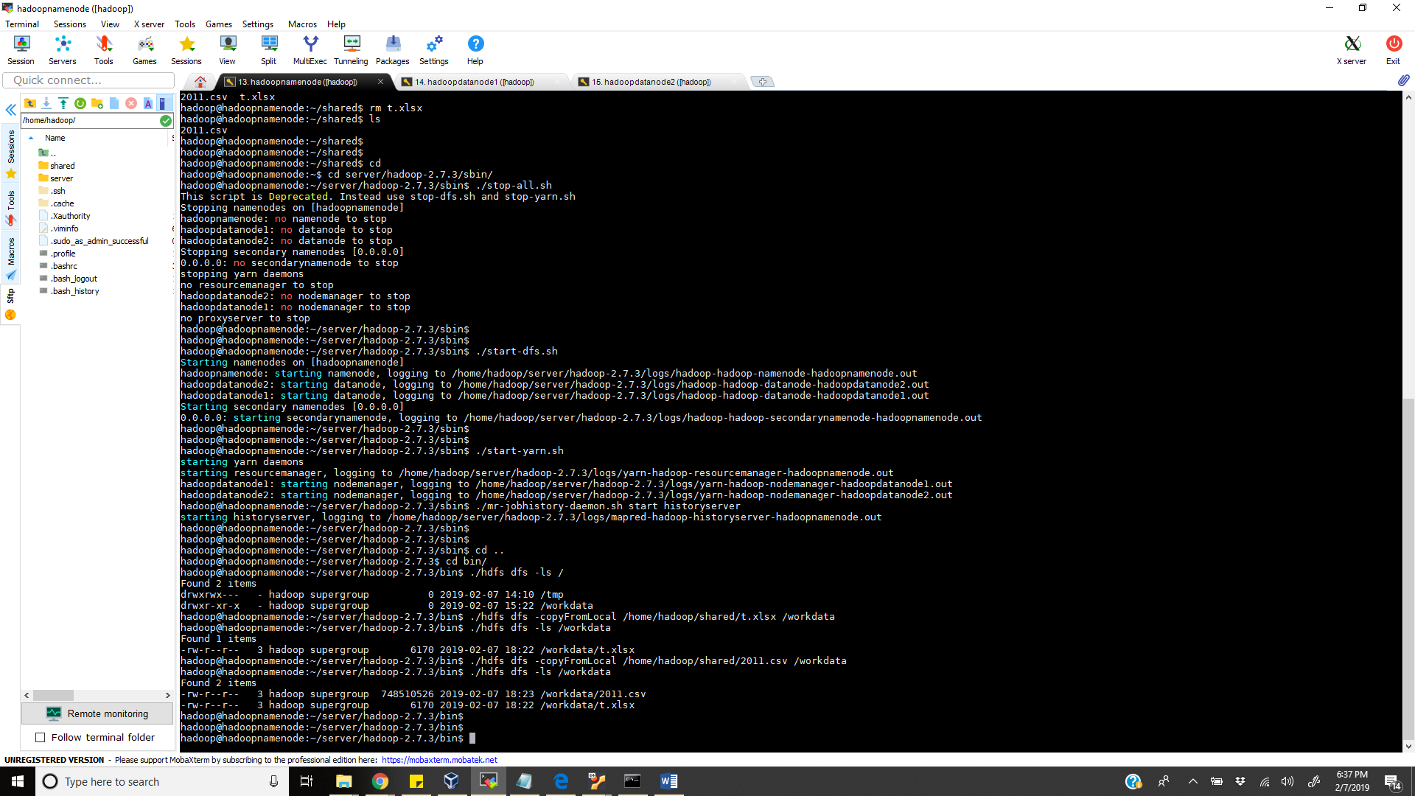

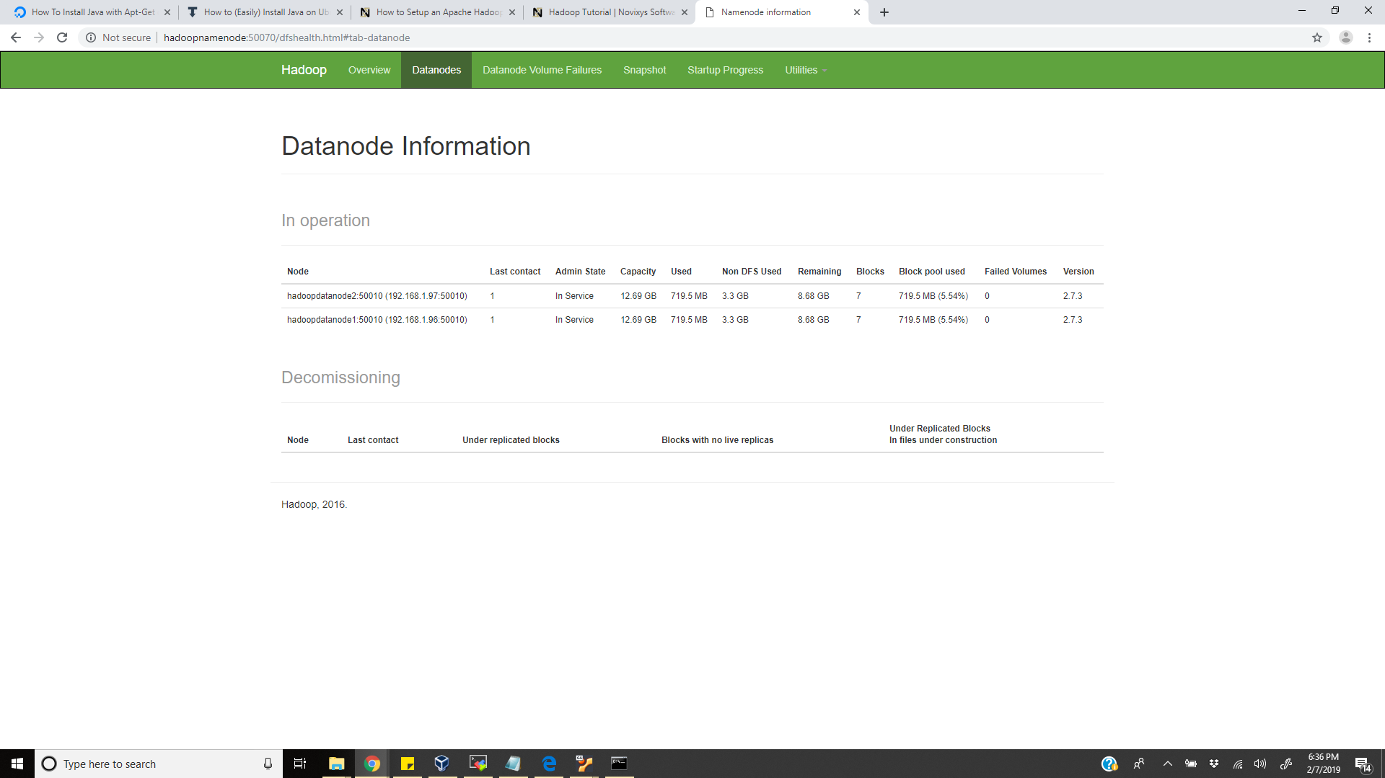

**Installation of pig:**

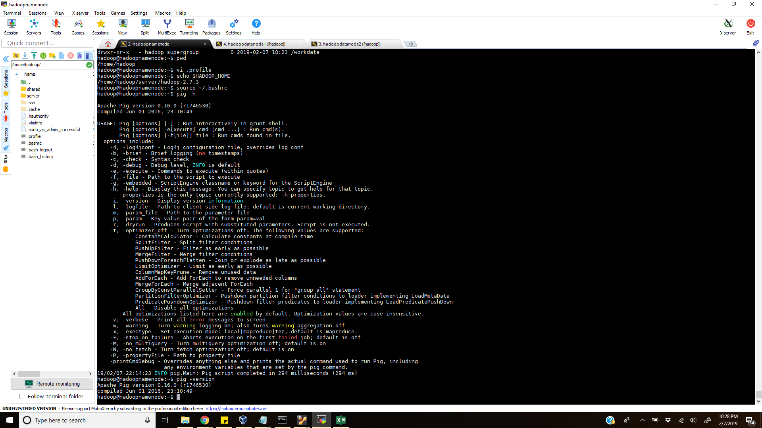

**Checking the blocks in data node:**

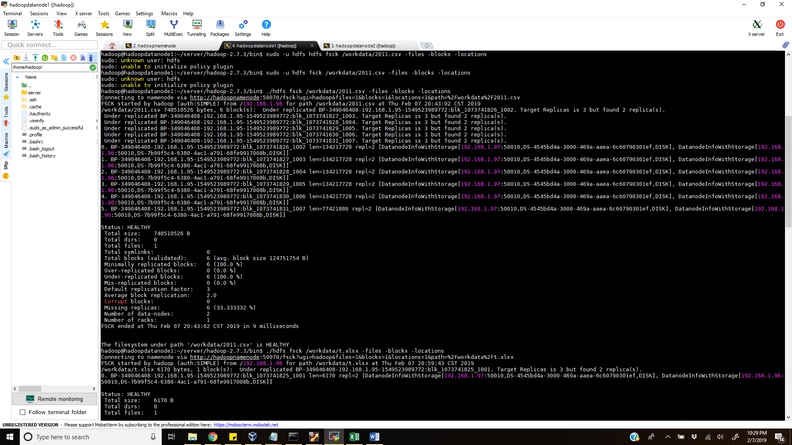

**Hadoop Cluster formation:**

**Files to execute command:**

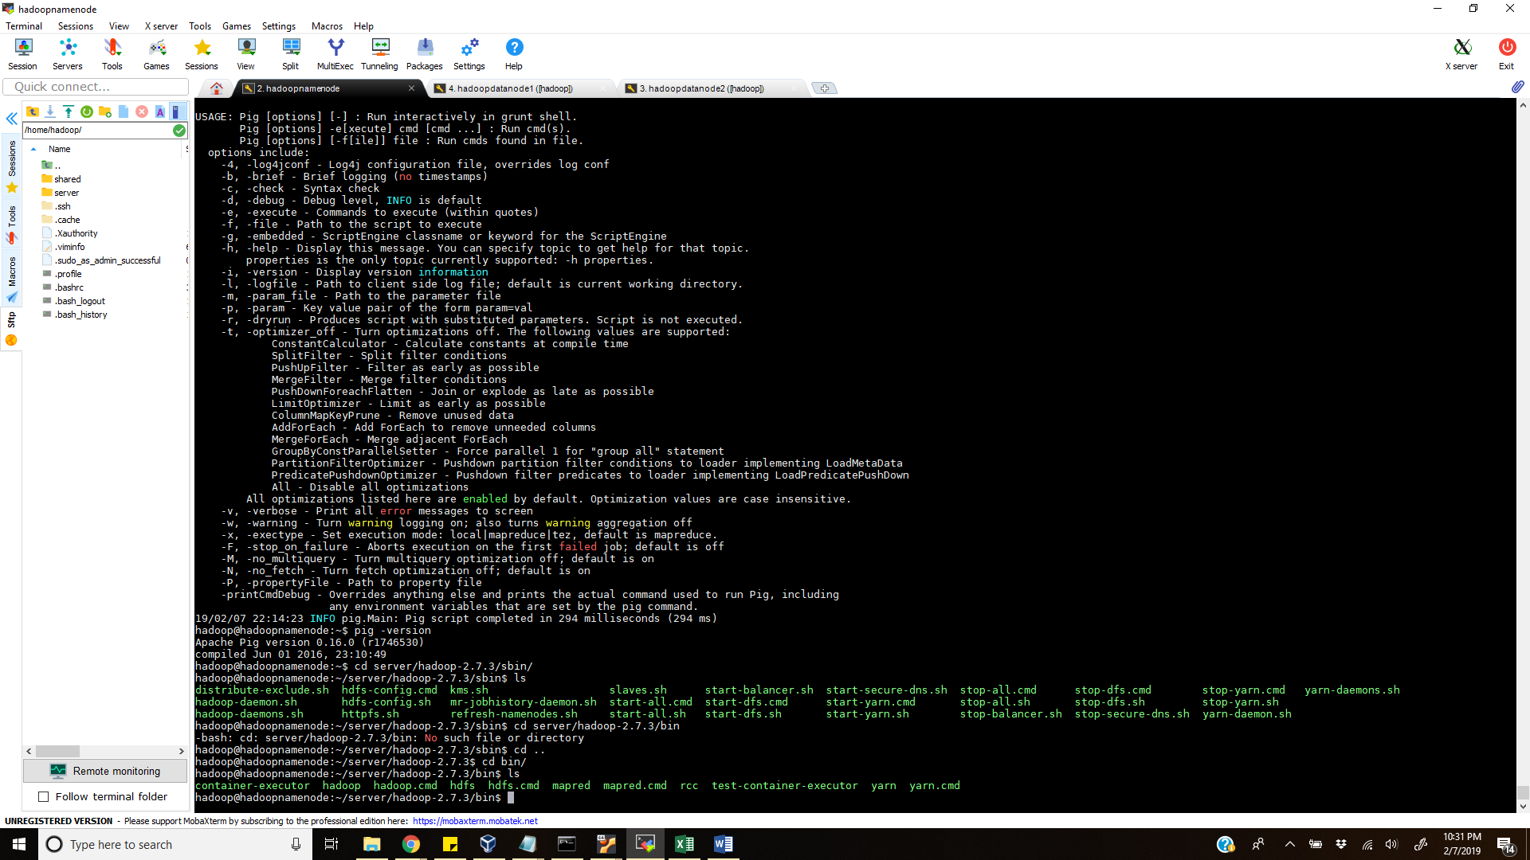

**Checking the process in namenode:**

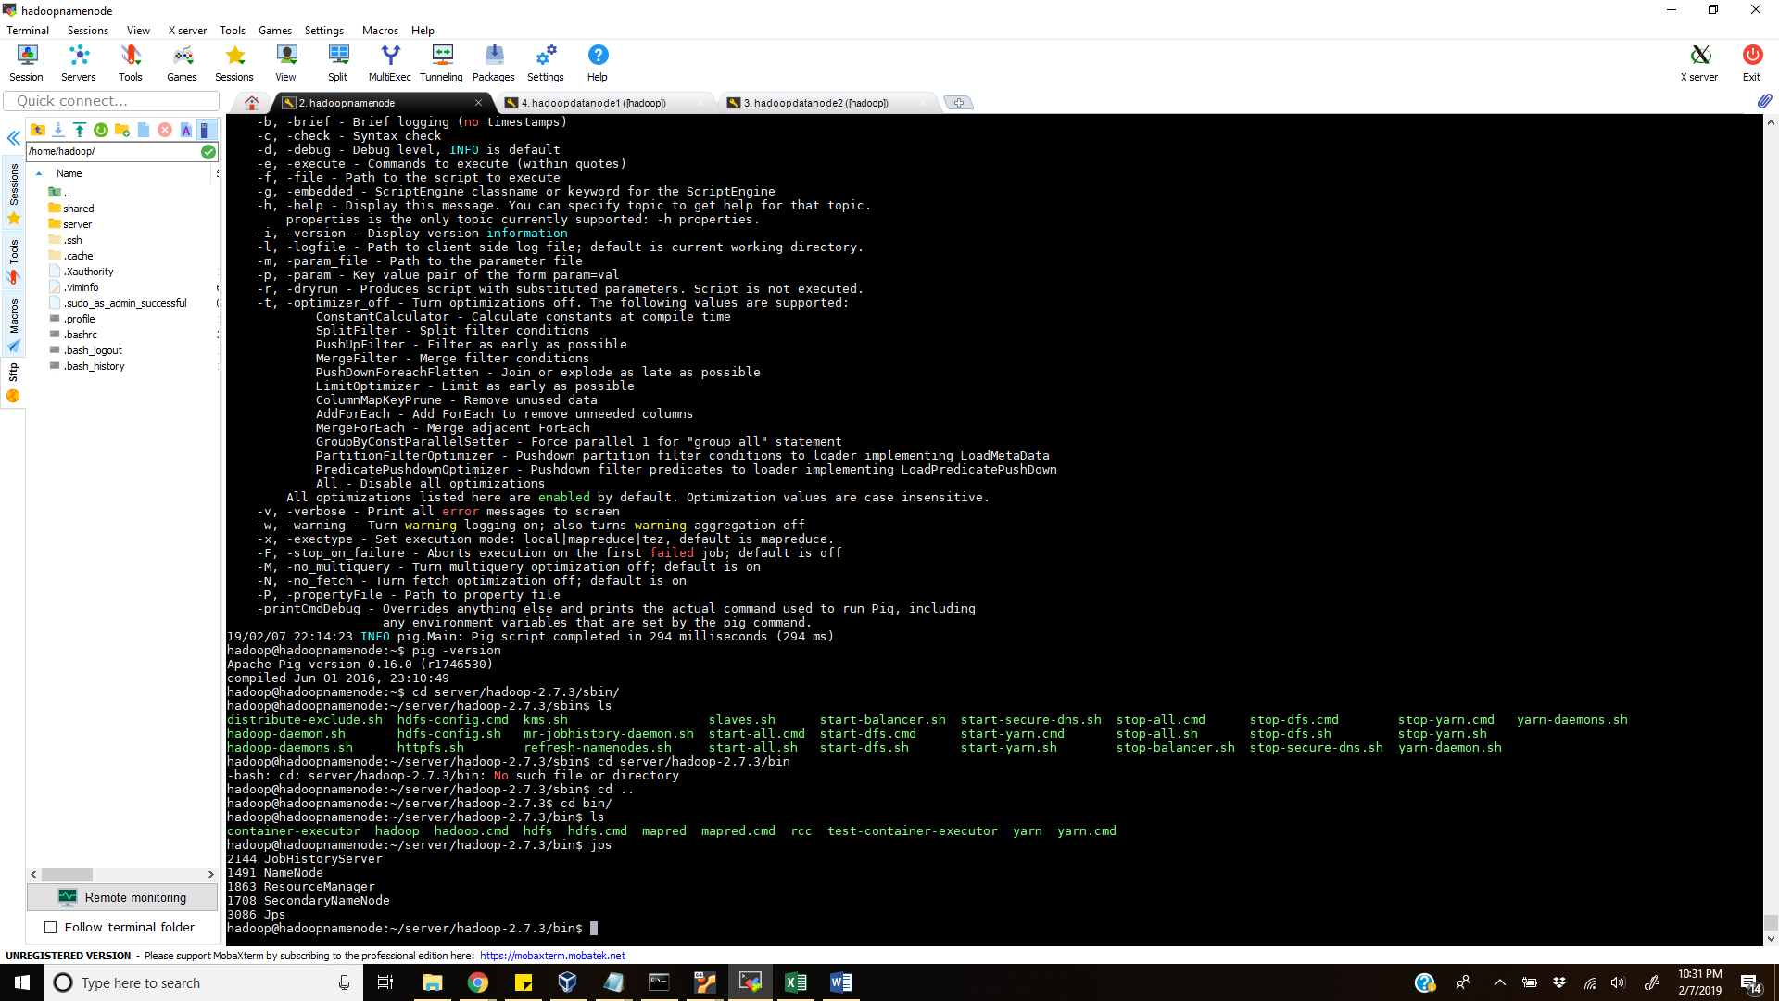

**Checking the process in data node:**

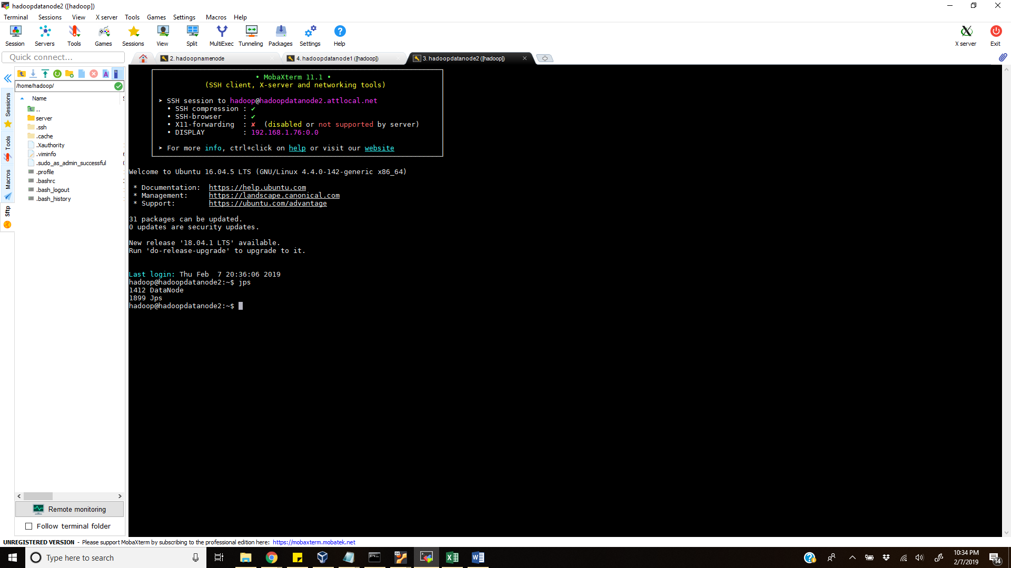

**PIG execution:**

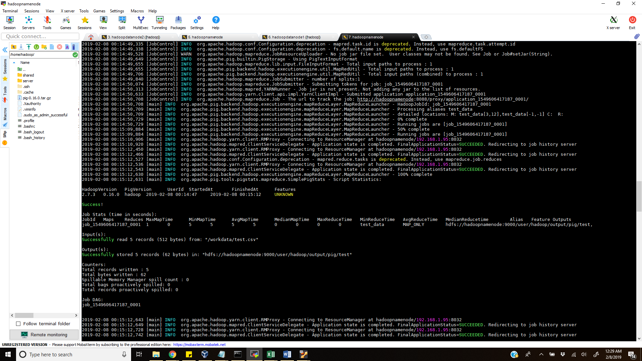

**GRUNT PIG execution:**

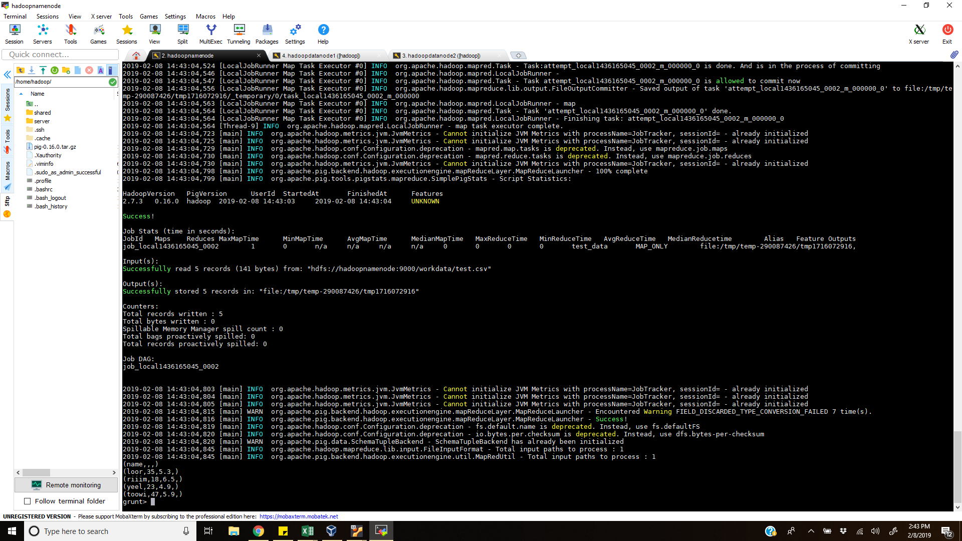

**PIG execution of getting selected data from excel:**

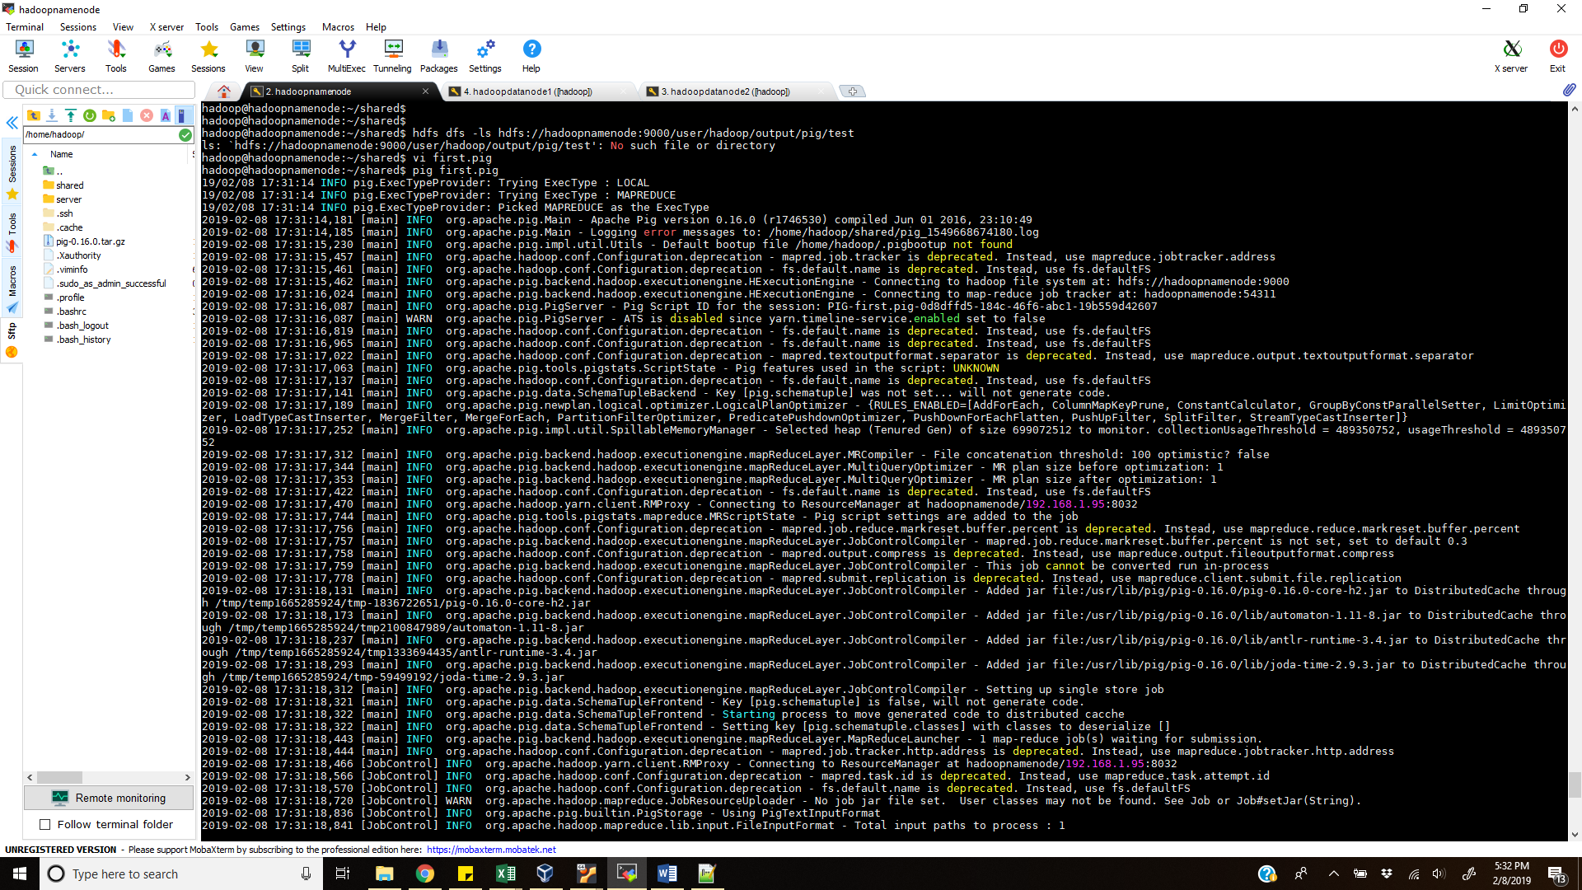

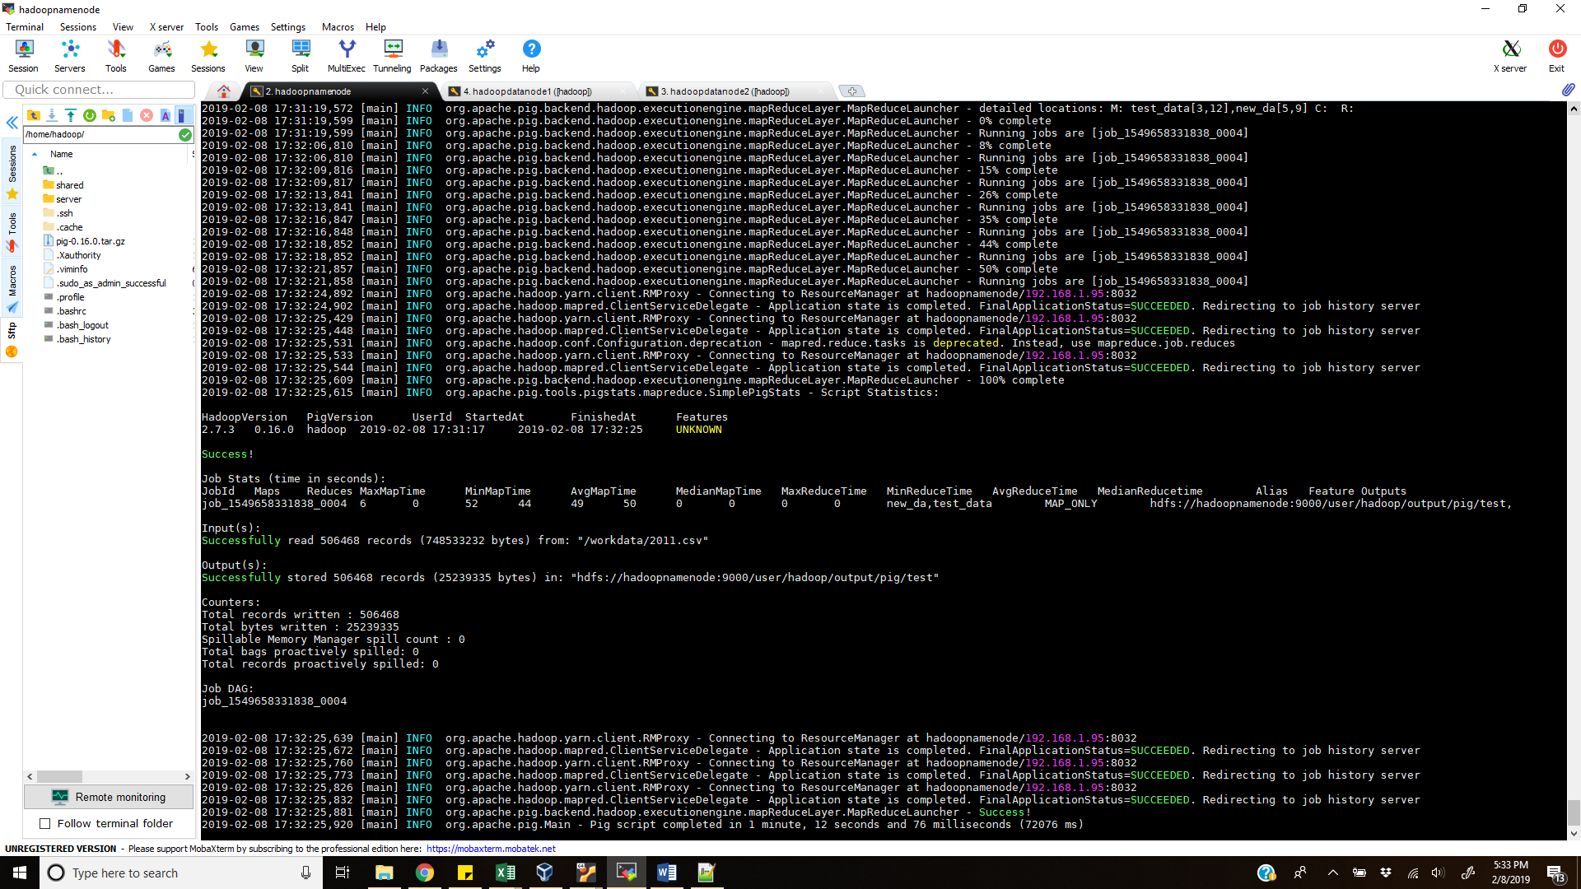

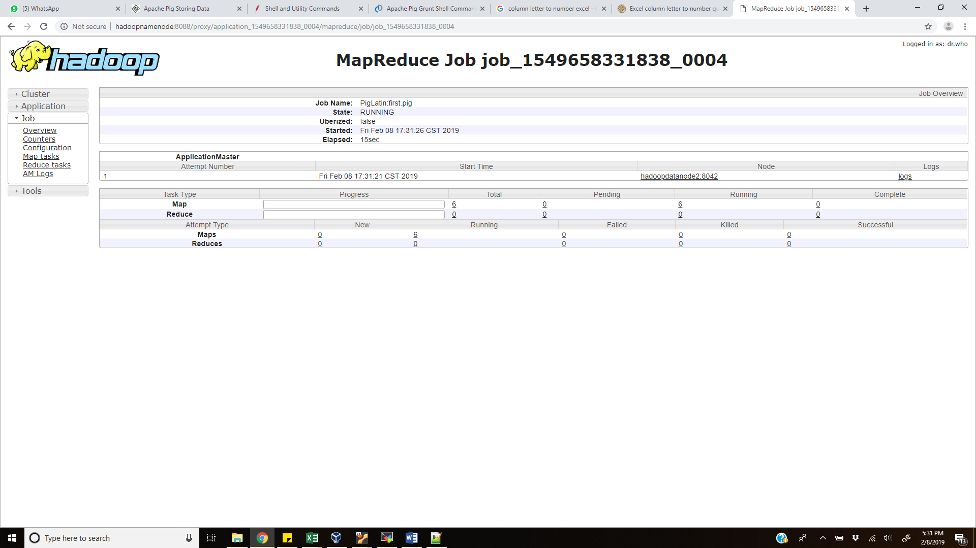

**MATPLOTLIB GRAPH COMMANDS:** 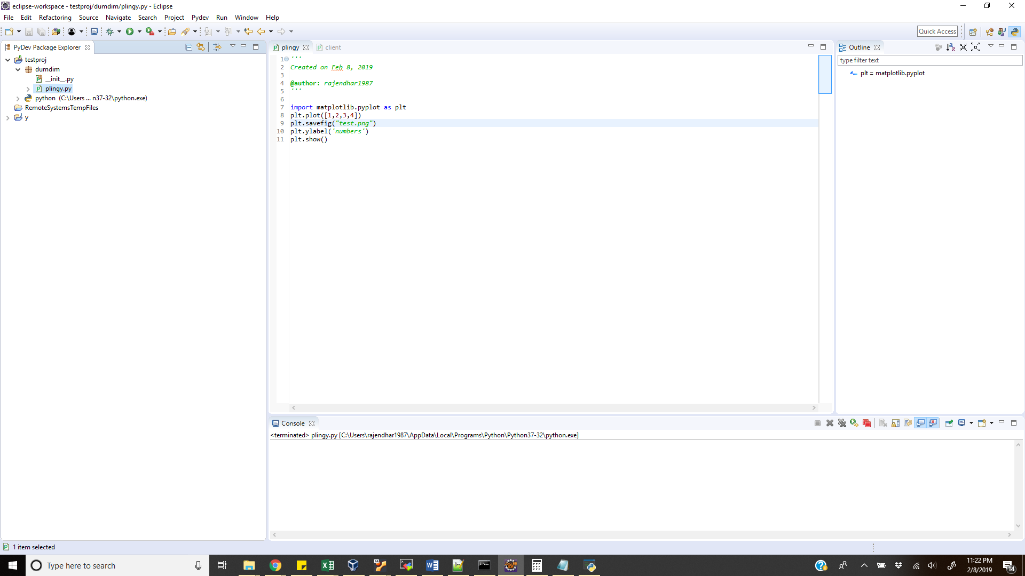

**HOW TO CONNECT TO HDFS:**

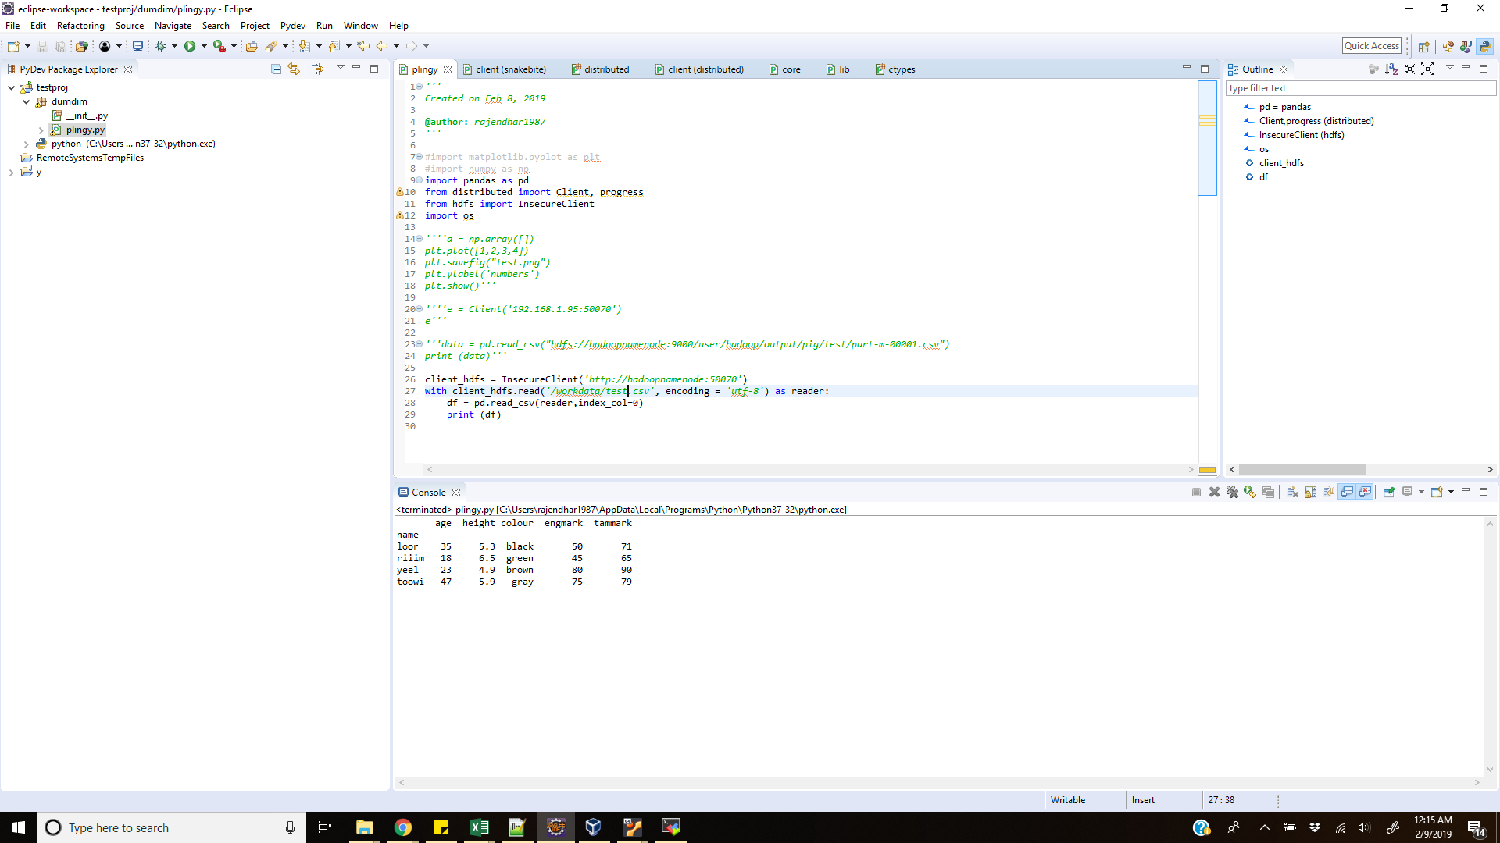

**Feb 26th:**

**Started HDFS and checked job:**

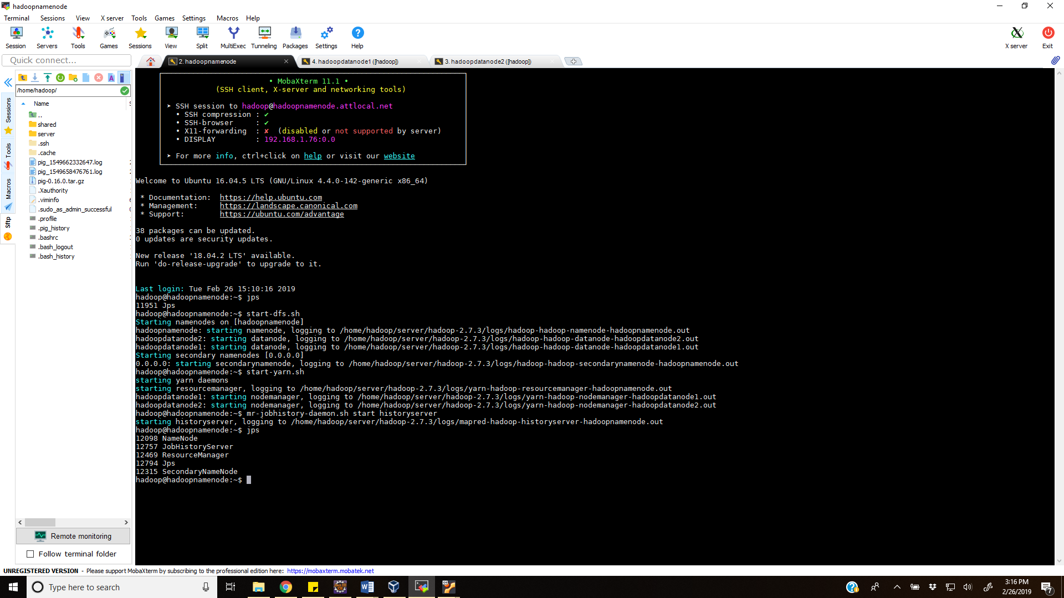

**Process running in data node:**

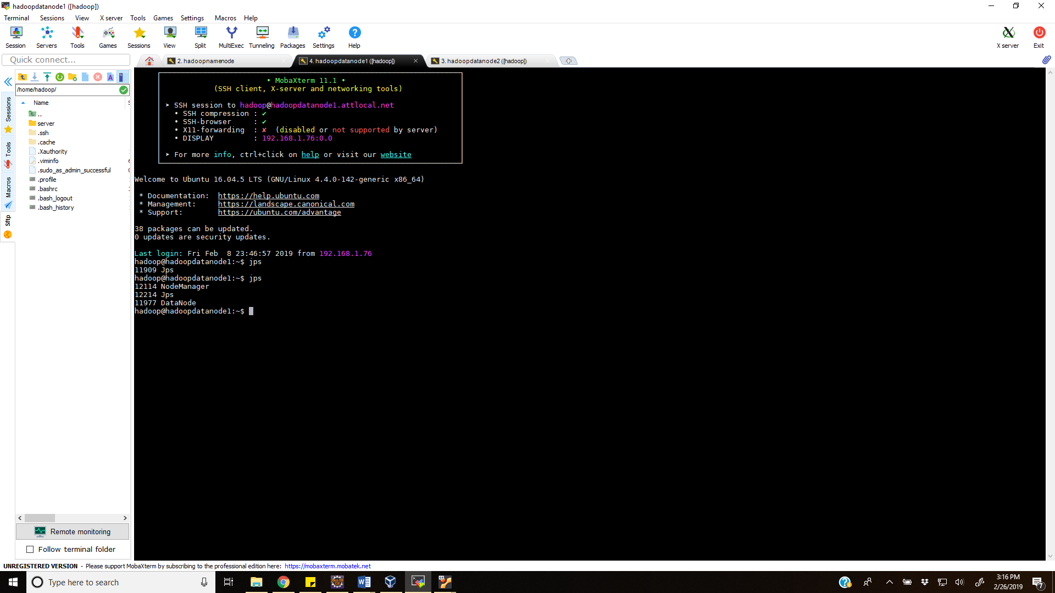

**Successfully copied 5-year data into local:**

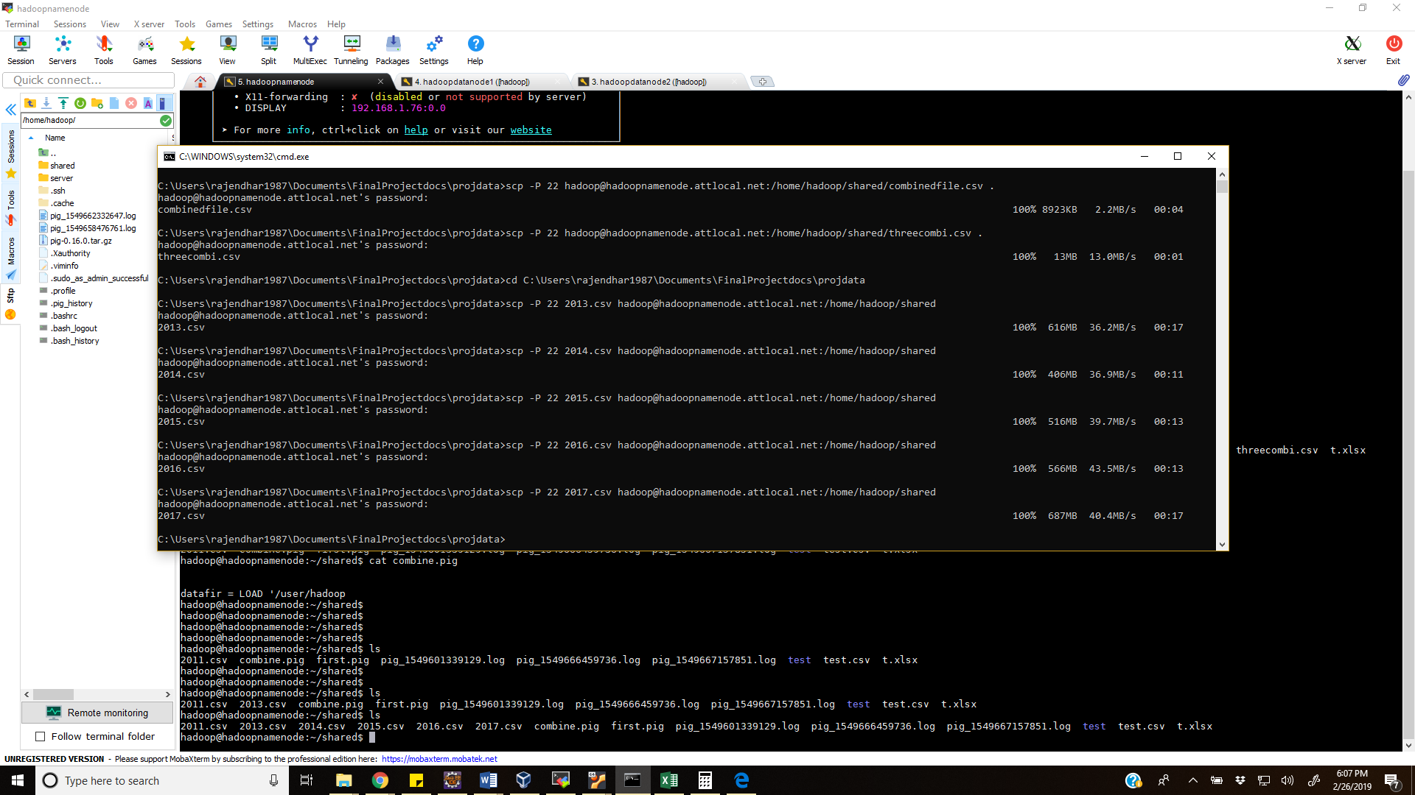

**Successfully uploaded 5 files in Hadoop dfs:**

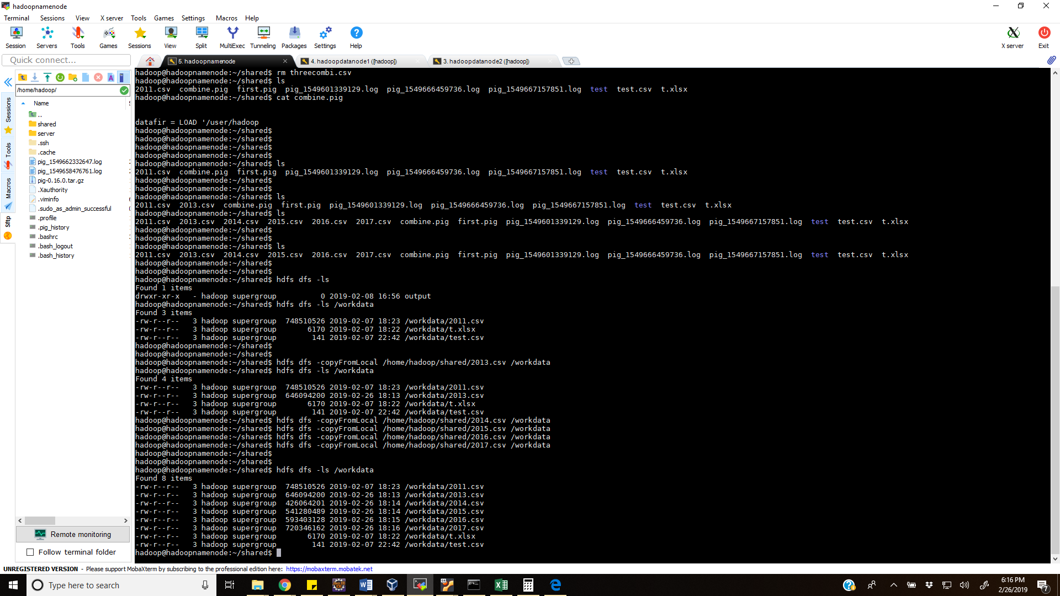

**After uploading 5 files:**

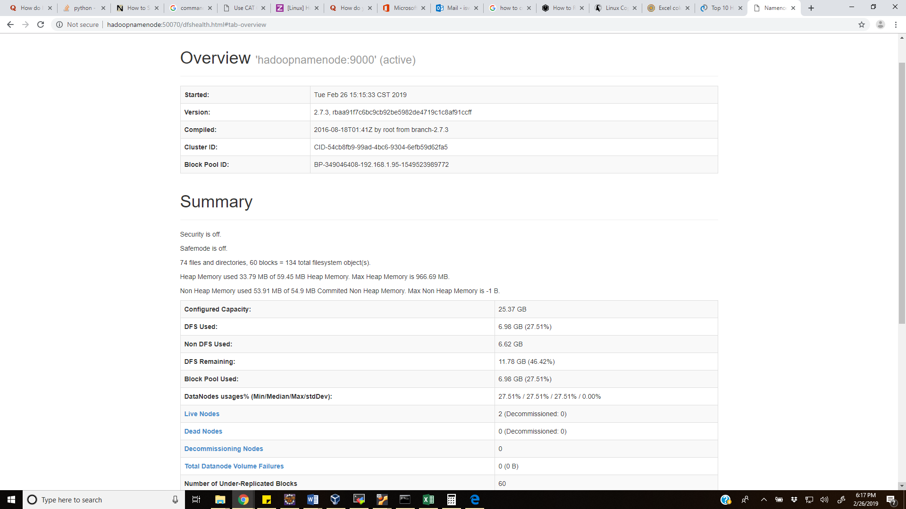

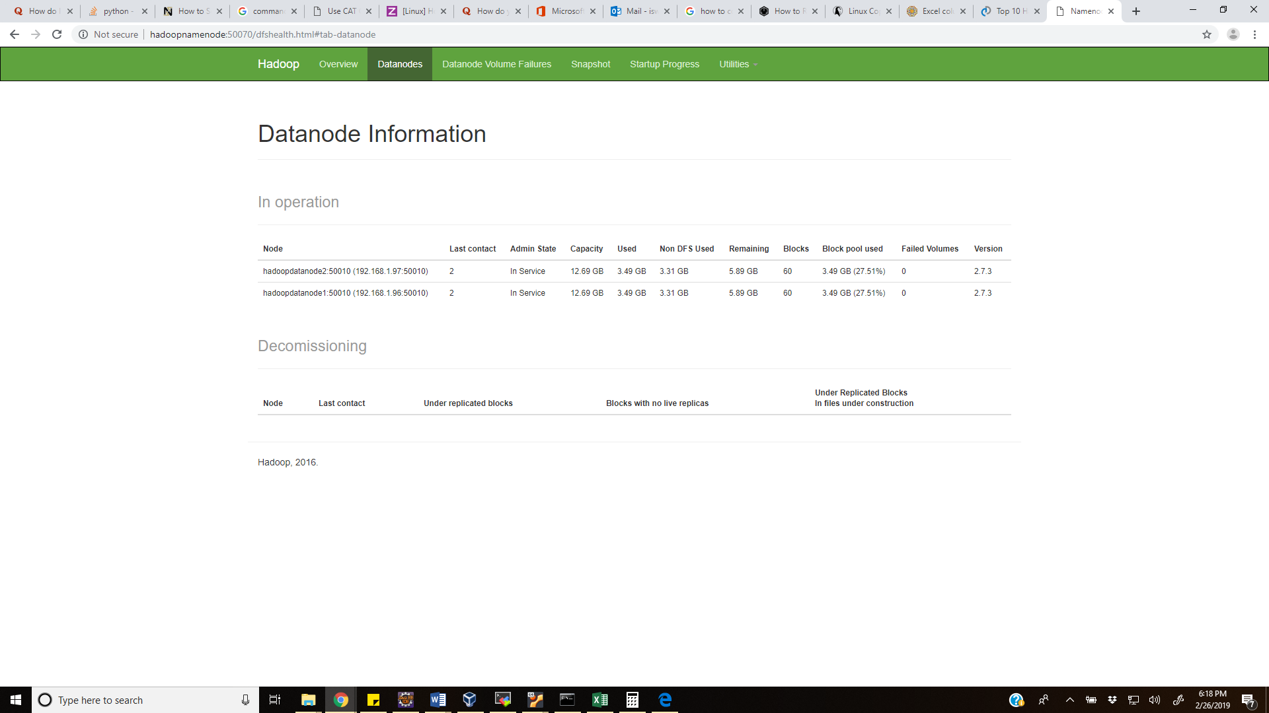

**MASTER AND 2 DATA NODES:**

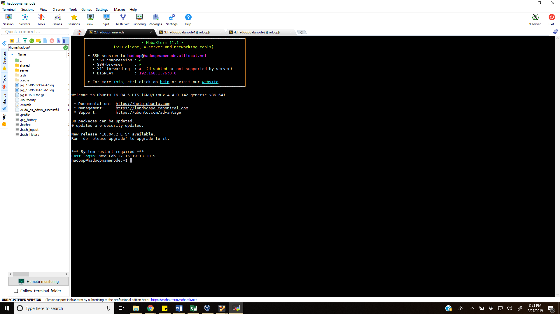

**Modified pig file:**

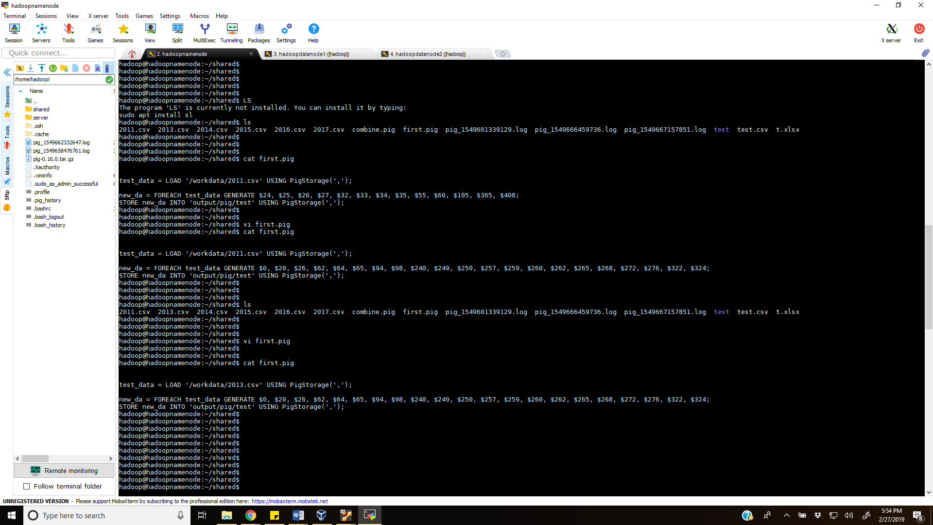

**Started pig:**

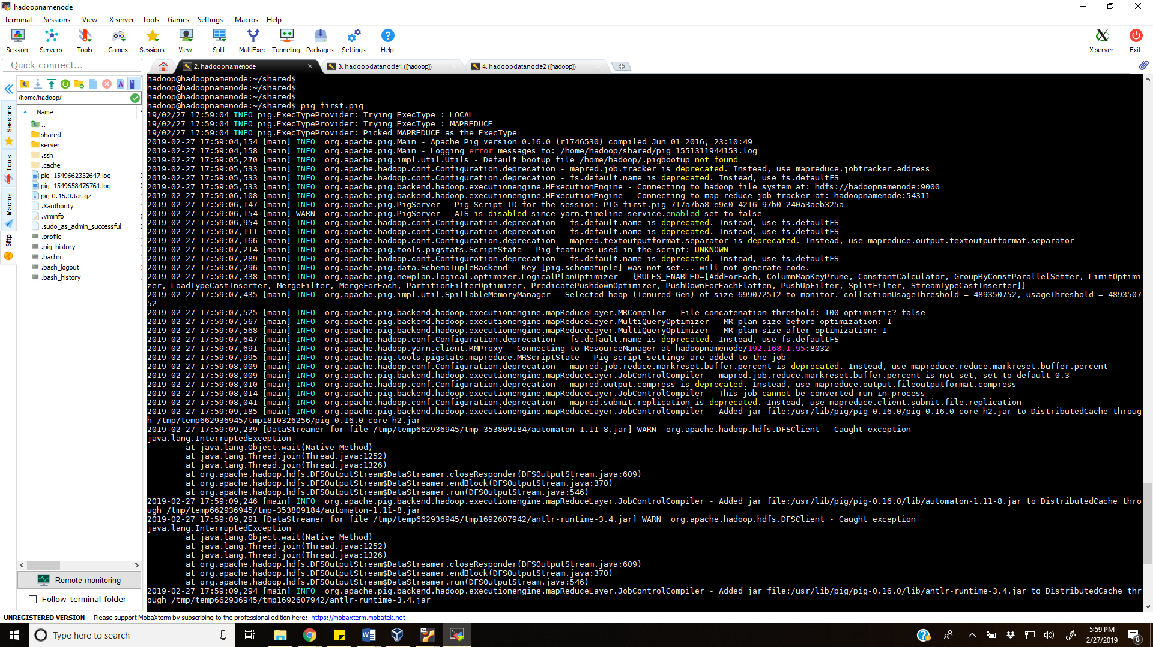

**Job running:**

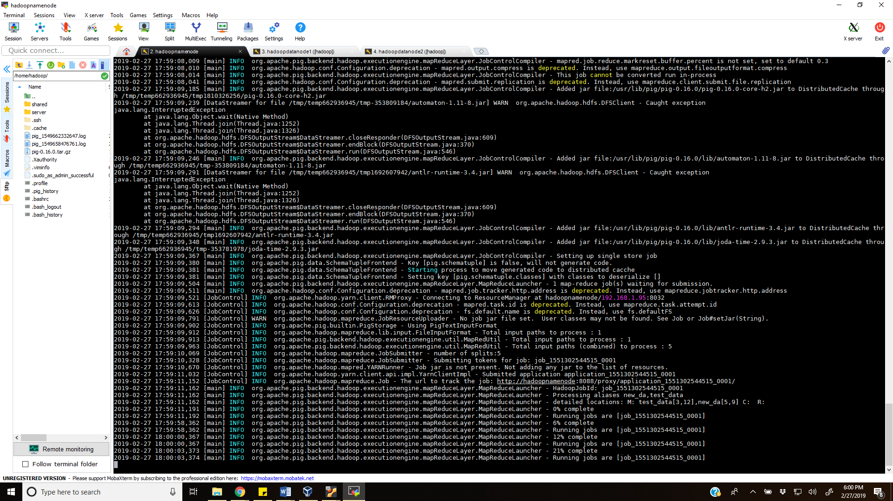

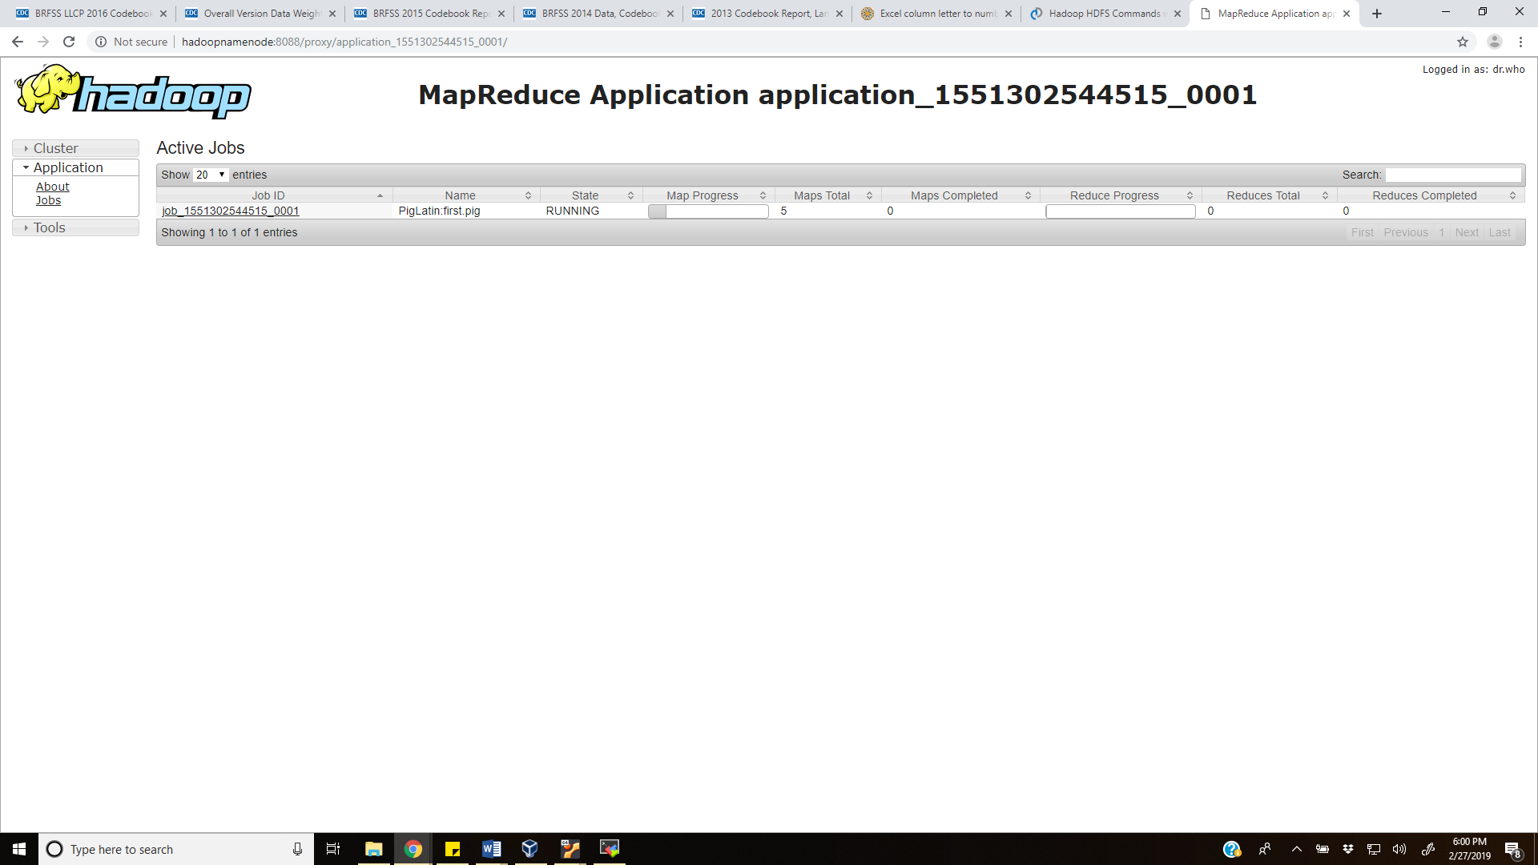

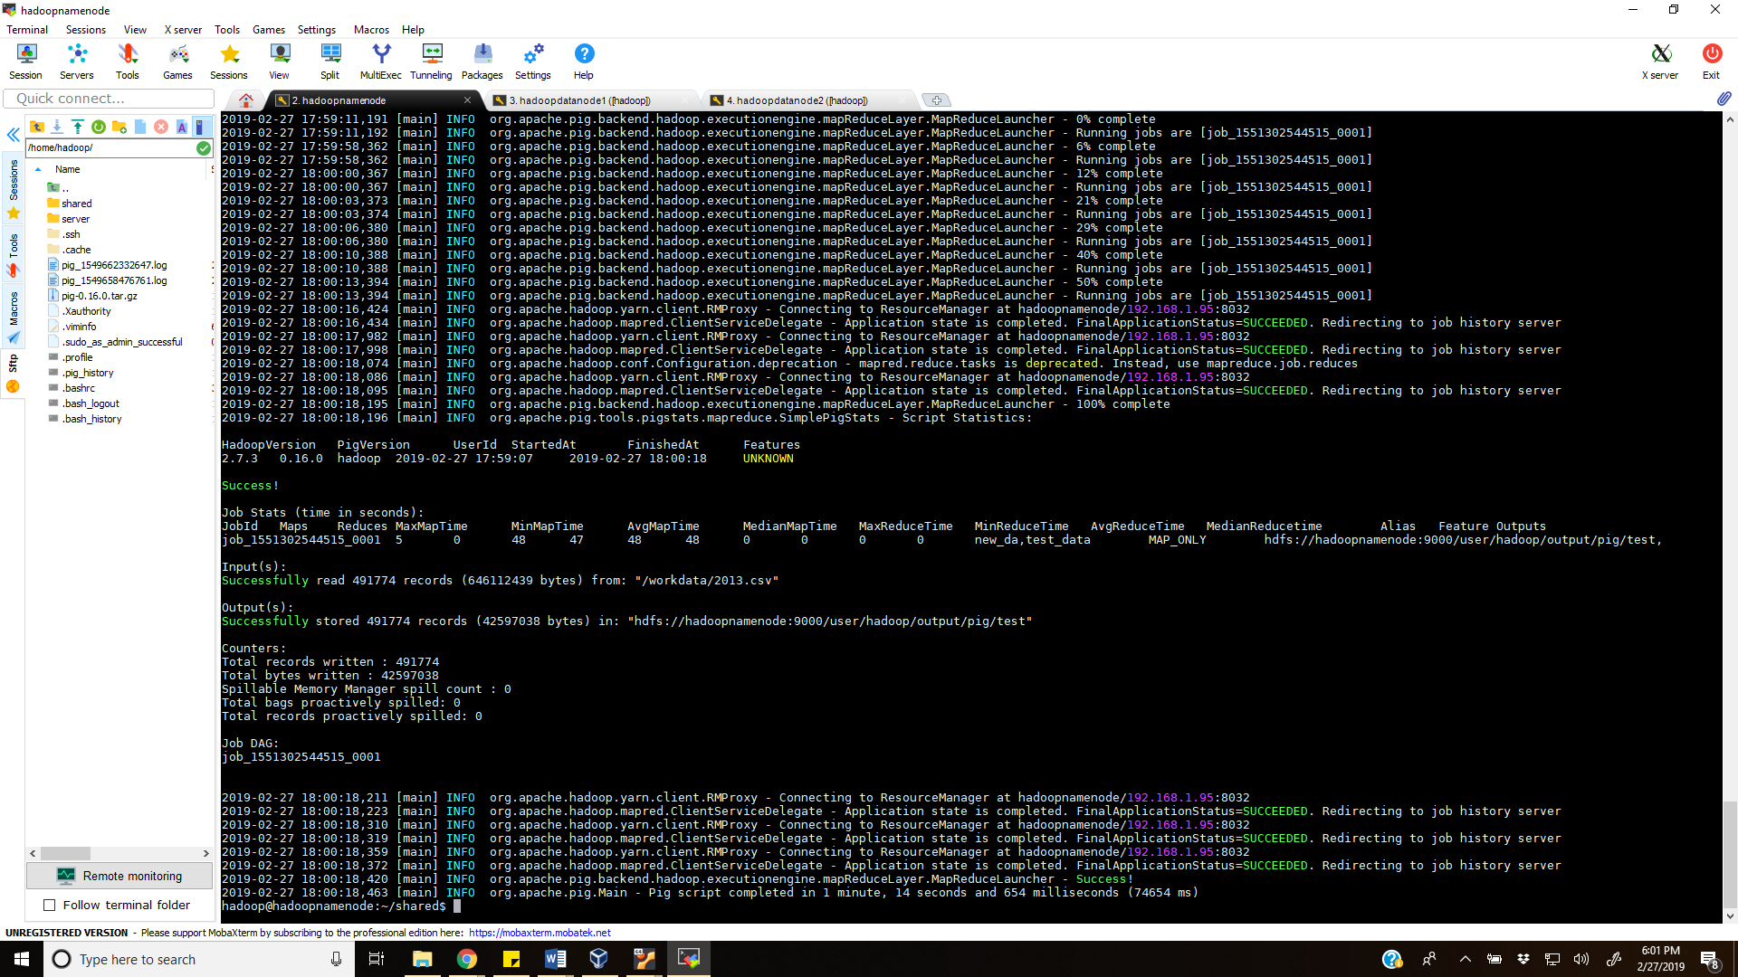

**Downloaded to local system to check:**

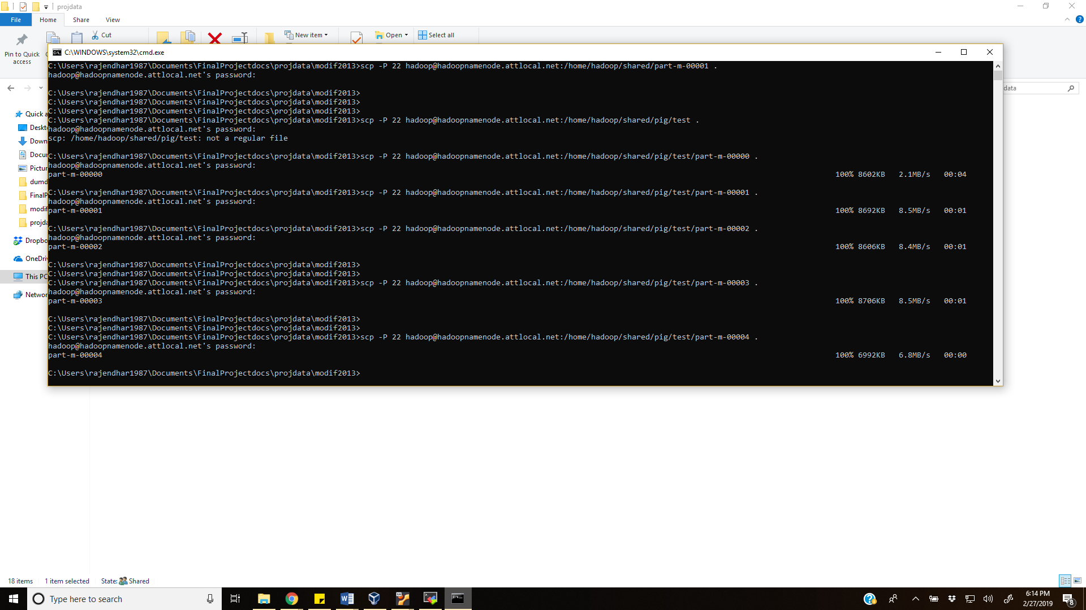

**Path for output Hadoop file:**

**hdfs://hadoopnamenode:9000/user/hadoop/output/pig/test**

**2014:**

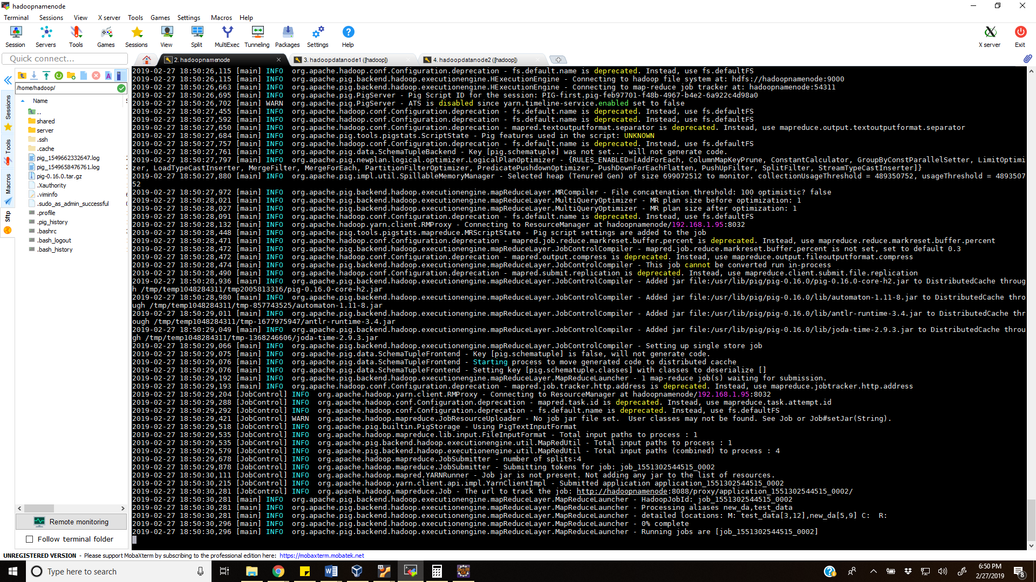

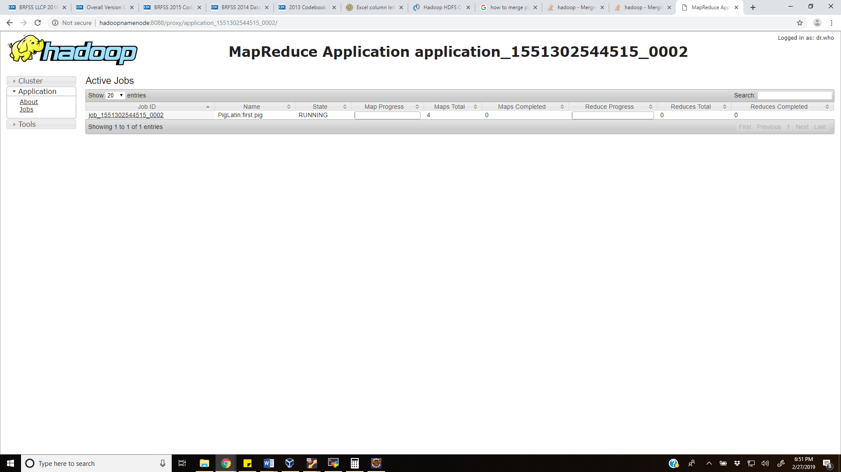

**Completed job in 1 min:**

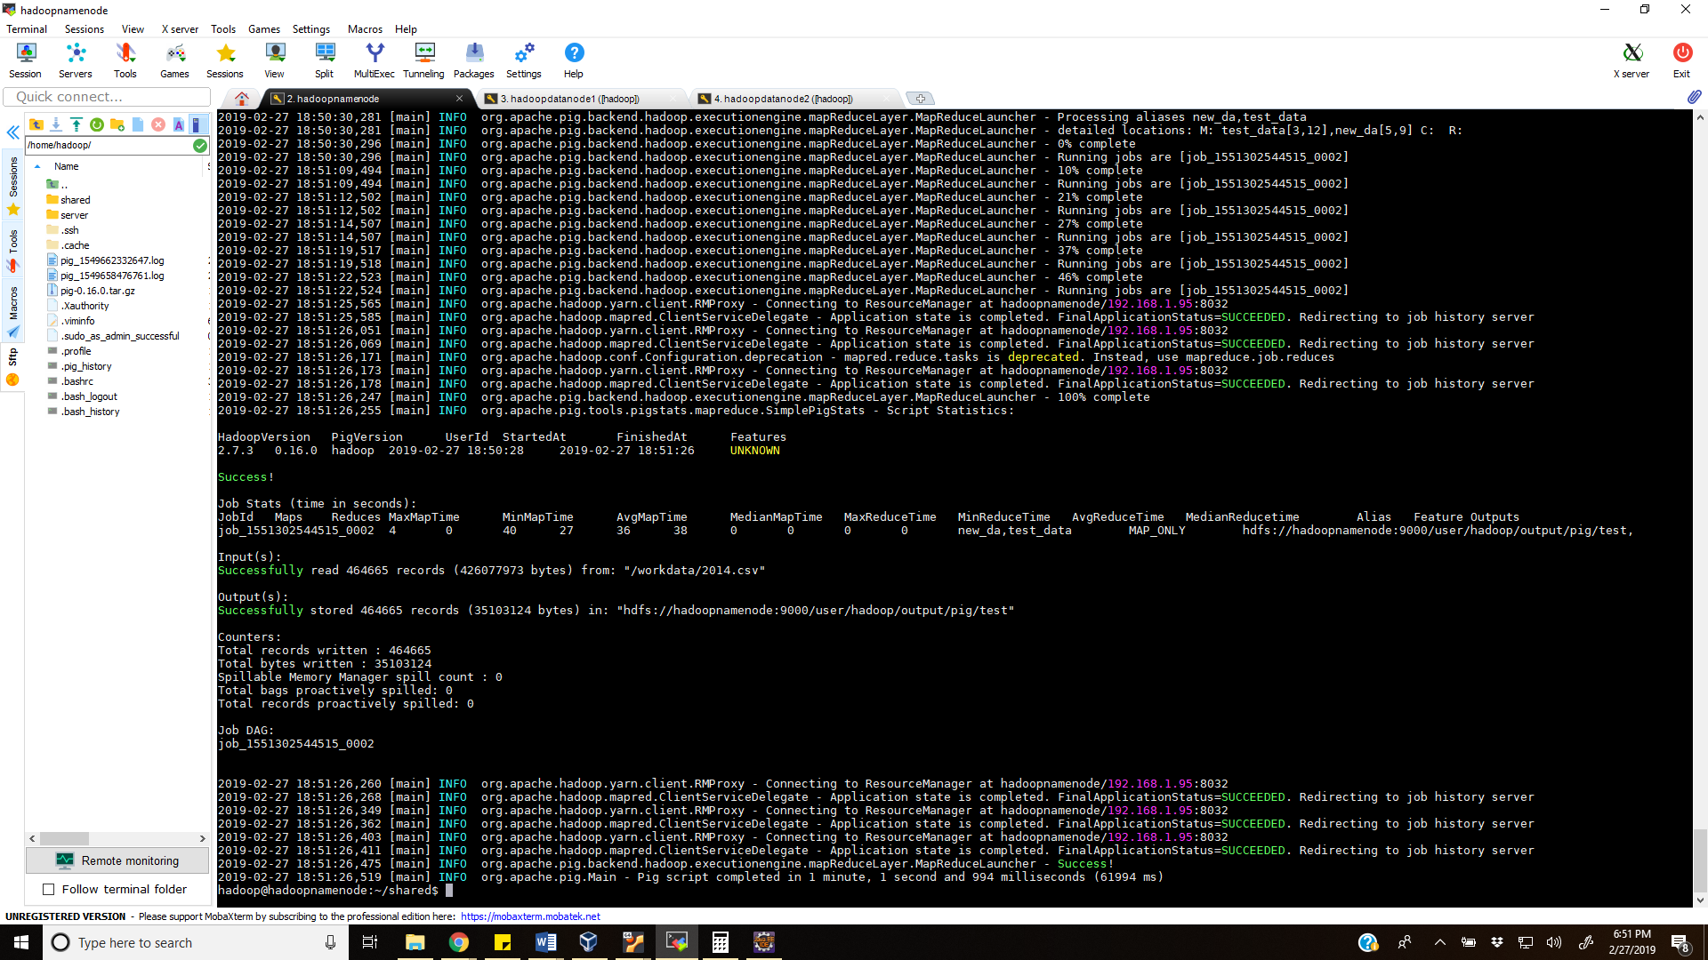

**2015:**

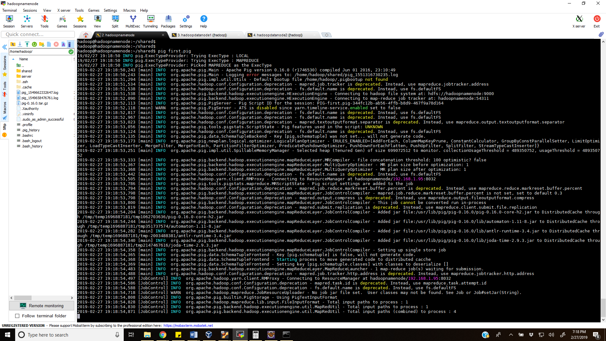

**Job completed in less than a minute:**

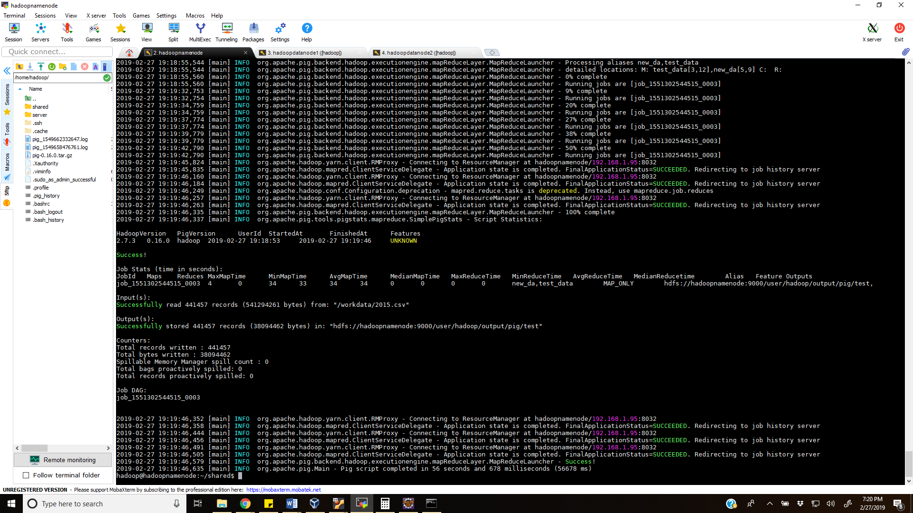

**2016:**

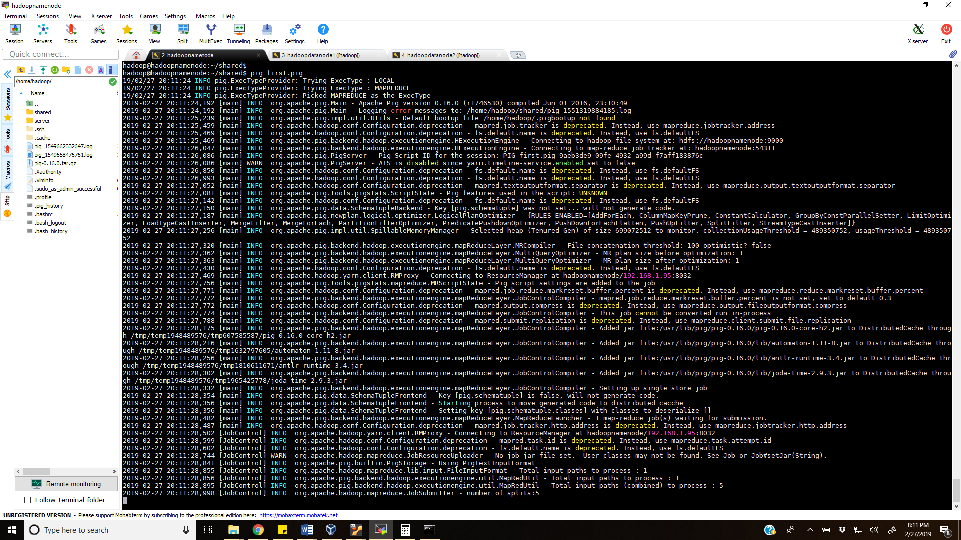

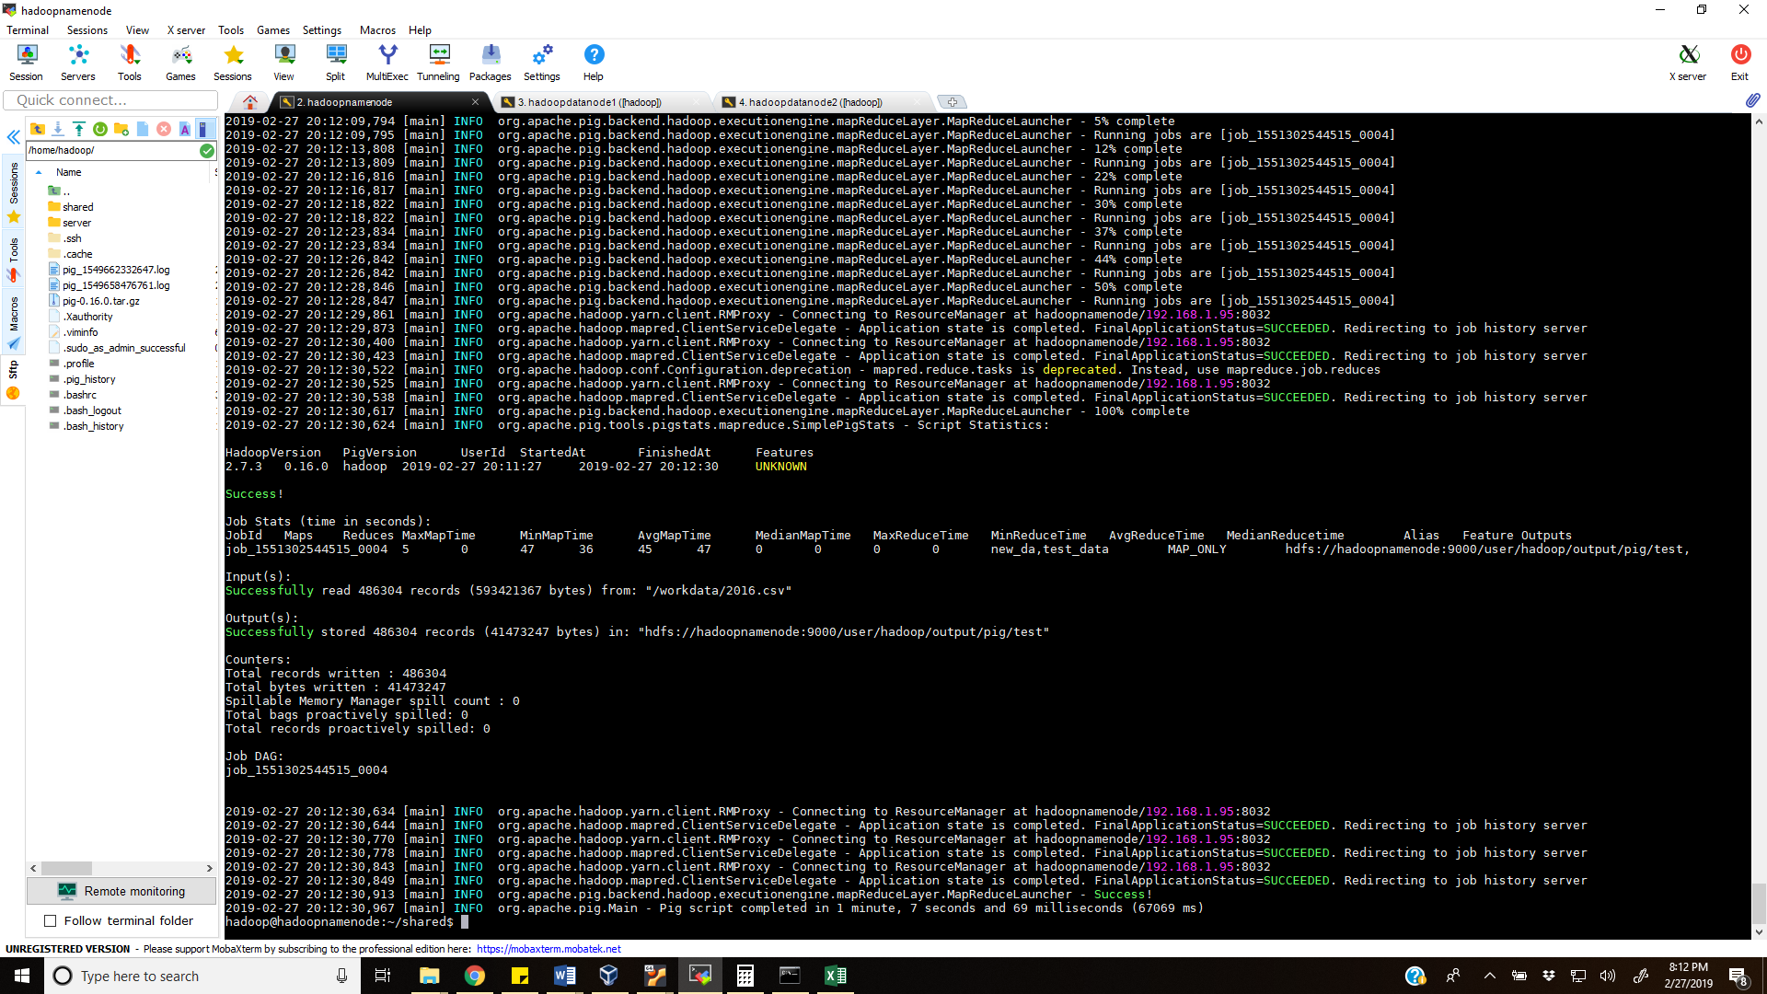

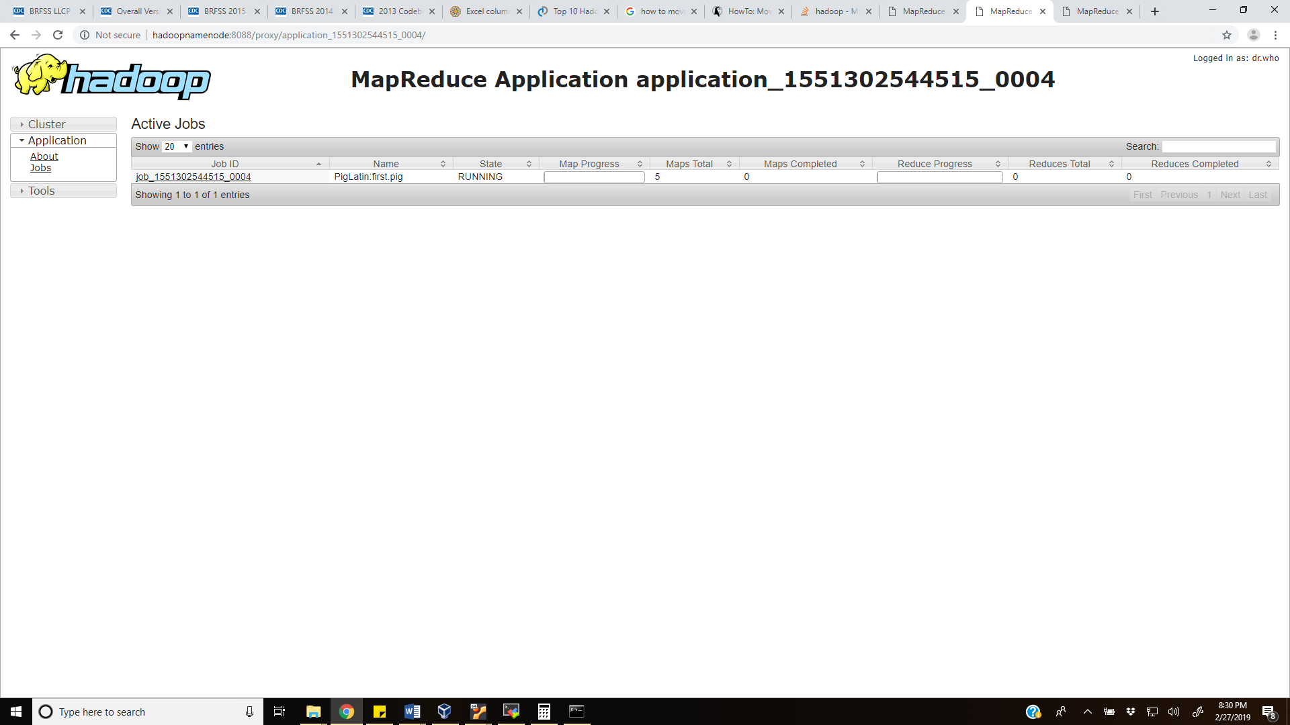

**2017:**

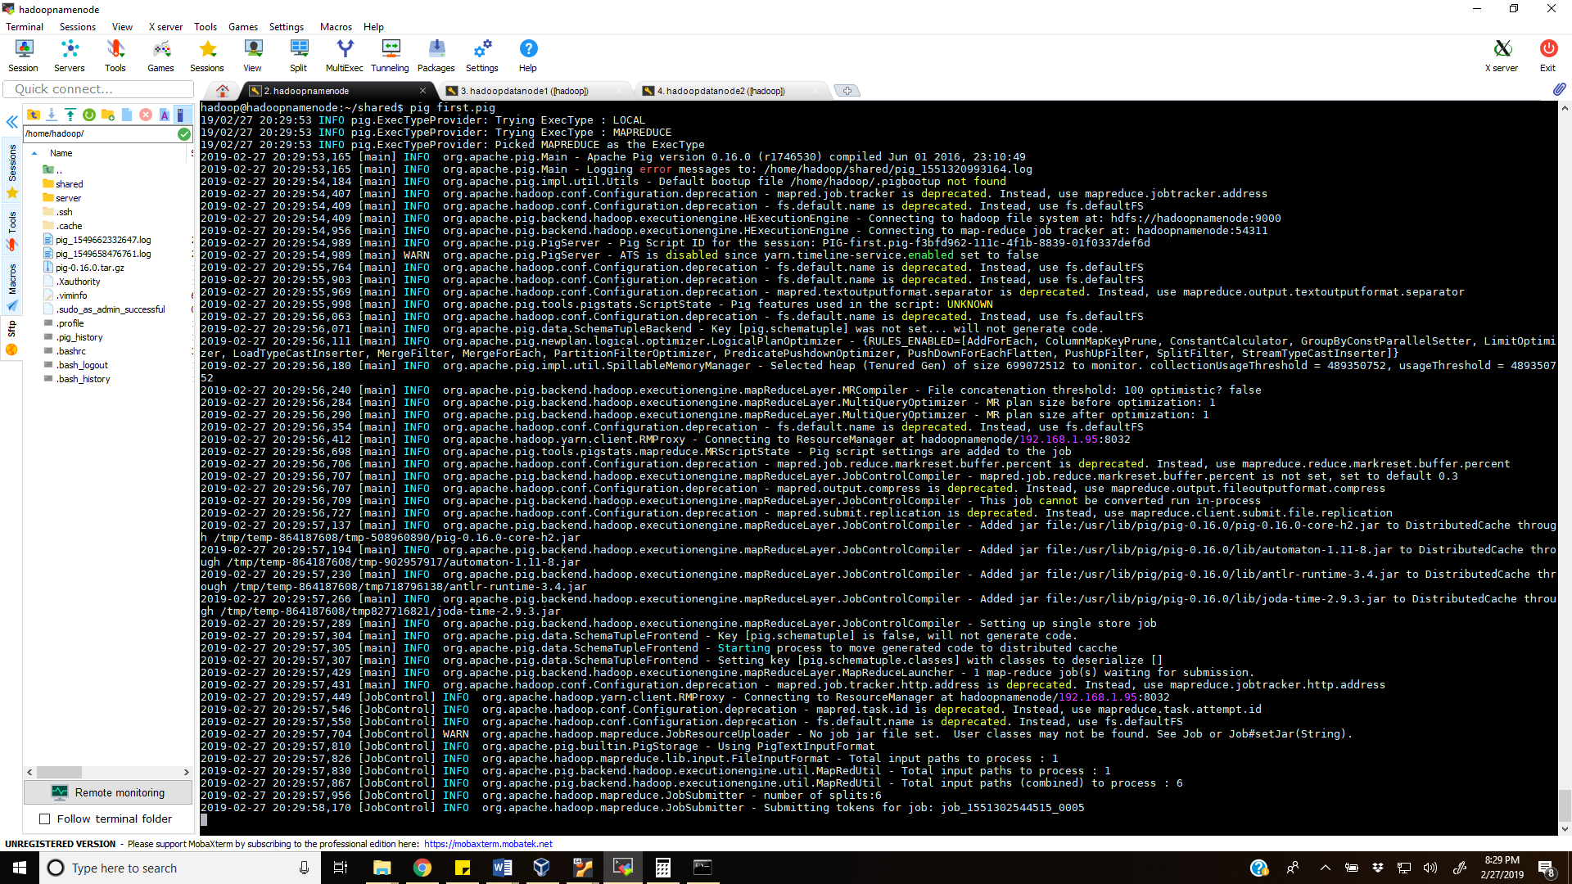

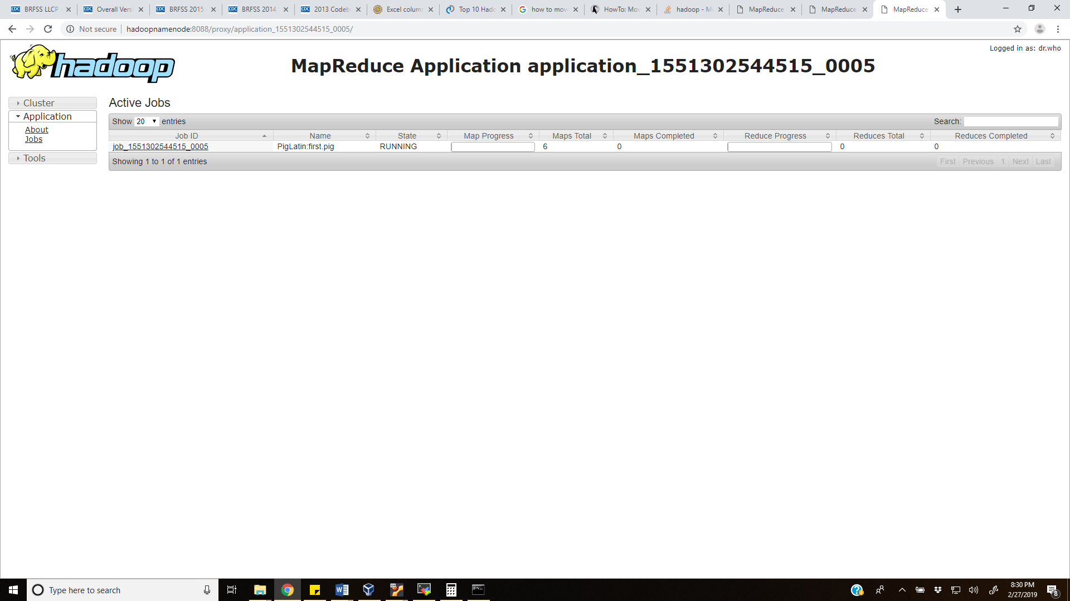

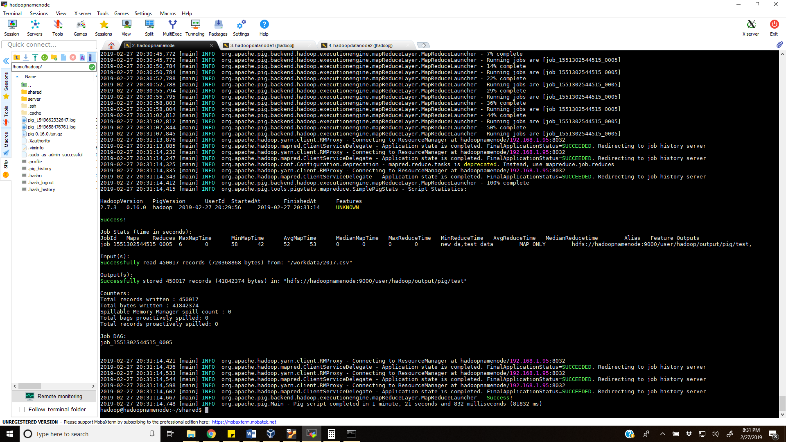

**http://hadoopnamenode:8088/proxy/application_1551302544515_0003/**

[**http://hadoopnamenode:8088/proxy/application_1551302544515_0004/**](http://hadoopnamenode:8088/proxy/application_1551302544515_0004/)

**http://hadoopnamenode:8088/proxy/application_1551302544515_0005/**

**CITATION FOR CDC DATA SET:**

Suggested Citation for Survey Questions:  
Centers for Disease Control and Prevention (CDC). Behavioral Risk Factor Surveillance System Survey Questionnaire. Atlanta, Georgia: U.S. Department of Health and Human Services, Centers for Disease Control and Prevention, [appropriate year].

Suggested Citation for Online BRFSS Database:  
Centers for Disease Control and Prevention (CDC). Behavioral Risk Factor Surveillance System Survey Data. Atlanta, Georgia: U.S. Department of Health and Human Services, Centers for Disease Control and Prevention, [appropriate year].